FASHION DEMAND FORECASTING USING MACHINE LEARNING AND DOMAIN ADAPTATION
Design and Implementation
Department of Computer Science and Engineering, TKR College of Engineering & Technology
Batch A17 (CSE-A) · Academic year [ACADEMIC YEAR]
Table 1: Project team
S.No. | Student name | Roll number
1 | B Shilpa | 23K91A0547
2 | B Hari Narayana | 23K91A0544
3 | A Rani Thejaswini | 23K91A0516
4 | A Sanjana | 23K91A0511

Project guide: Deepthi
Chapter and section numbers quoted in the text (for example Chapter 8 or Section 6.2) refer to the full project report, 17.Final Document. Figures and tables in this document are numbered from 1.

1. DESIGN
This chapter describes how TrendCast is put together: the architecture and workflow, the data flow, the UML and data design, the modules, the API and the user interface. The diagrams were drawn from the code in src/ and backend/; the complete set, each with a longer explanation, is also in the Block Diagrams document. A note on scope: the product is a single-user analysis tool. It has no accounts, no database and no scheduler, and these absences are design choices that the sections below explain rather than hide.

1.1 Design goals and architecture
Five goals shaped the design. First, every number on screen must be computed from the uploaded files: nothing is hard-coded, and the project guide can upload a different slice of the H&M data and see different results. Second, no data leakage: lag and rolling features are shifted by one day, the train and test sets are split by date, and hyperparameters are tuned with time-ordered folds. Third, honest evaluation: every error is reported as measured, including negative improvements. Fourth, gating: a page that needs an earlier step refuses to run and says which step is missing. Fifth, a thin web layer: the machine-learning code stays in the src/ package and is shared by the original Streamlit pages and the new web console, so the two cannot disagree.
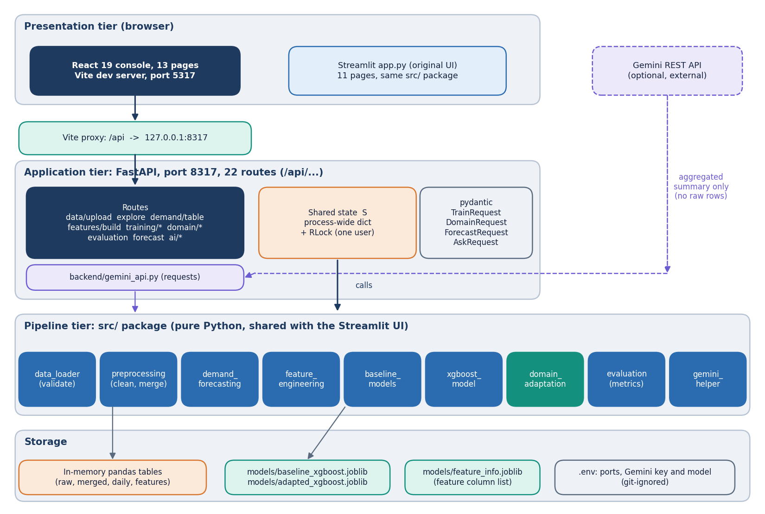
Figure 1: Layered architecture of TrendCast: React console, Vite proxy, FastAPI application with 22 routes, the src/ pipeline modules, and in-memory state plus joblib model files.
The React 19 console on port 5317 reaches the FastAPI application on 127.0.0.1:8317 through the Vite development proxy, so the browser sees one origin. The application exposes 22 routes. It keeps a single process-wide dictionary of pipeline state, guarded by a re-entrant lock, in the way the Streamlit pages used st.session_state. Each route calls the same functions as the corresponding Streamlit page; only the HTTP and JSON handling is new. The two src/ modules that import Streamlit (data_loader, gemini_helper) are used for their validators and context builder only, and the backend lowers the Streamlit logger to avoid its no-runtime warnings.
The deliberate gaps in this architecture are worth stating. There is no authentication because the tool runs on one machine for one analyst; the CORS list therefore allows only localhost:5317 and 127.0.0.1:5317. There is no database because the data are re-uploaded for each analysis and the pipeline takes seconds, not hours (Chapter 7 lists the measured stage times); only the trained models are persisted. State is shared by every browser tab, so two analysts on one server would overwrite each other; this is acceptable for a demonstration and is listed as a limitation in Chapter 9.

1.2 High-level workflow
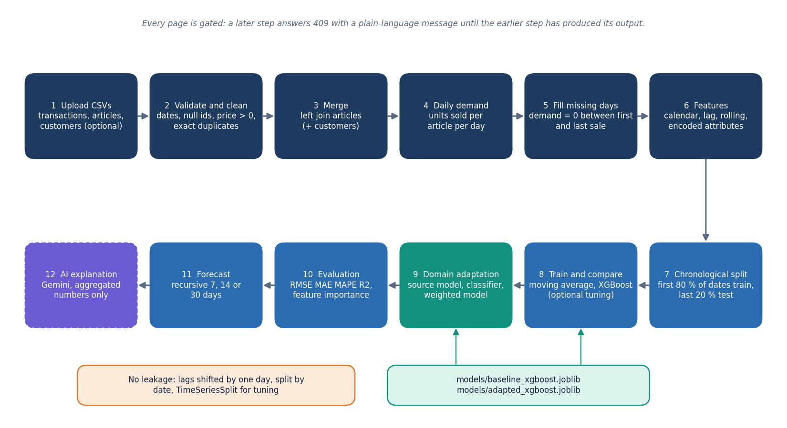
Figure 2: End-to-end workflow: upload, clean and merge, daily demand, features, chronological split, baseline and XGBoost, domain adaptation, evaluation, forecast and optional AI explanation.
The workflow has eight stages and every stage maps to one page of the console. Upload reads the files and returns the quality report. Explore and Demand show the aggregated series. Features builds the 31-input table. Training splits by date, fits the moving average and XGBoost and keeps the comparison. Domain trains on a source and tests on a target, with and without weights. Evaluation collects the comparison, the before-and-after table and the feature importance. Forecast rolls a chosen article forward. Insights asks Gemini to explain what is already on screen.
The console shows the stage reached through the nine flags of /api/state. A small provider component reads that route at start-up and again after each action, and every page wraps its content in a gate: if the flag it needs is false it shows the missing step with a link instead of calling an endpoint that would answer 409. This keeps the browser console free of expected errors and means a page reload restores the progress indicators from the server rather than from browser storage.

1.3 Data flow diagrams

1.3.1 Level 0: context
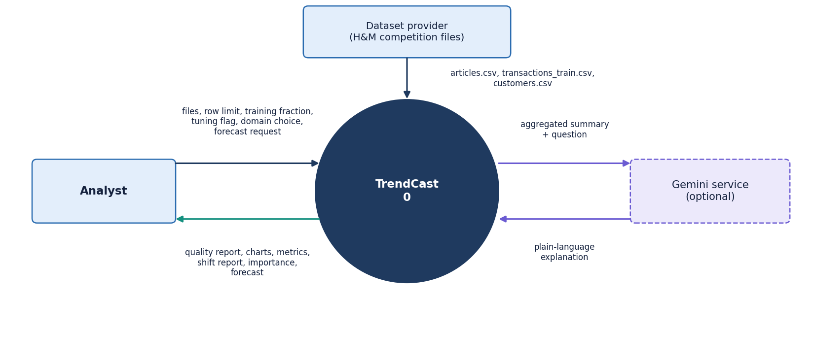
Figure 3: Context diagram (DFD level 0): TrendCast as one process with the analyst, the dataset provider and the optional Gemini service.
At level 0 TrendCast is one process with three external entities. The analyst supplies files and choices and receives reports, charts, metrics and forecasts. The dataset provider is the source of the three CSV tables, which in this project are the public H&M competition files. The Gemini service is optional and receives only an aggregated JSON summary and a question. Drawing the dataset provider and the analyst separately is deliberate: the product never downloads data, so every dataset arrives through the analyst's upload.

1.3.2 Level 1: seven processes
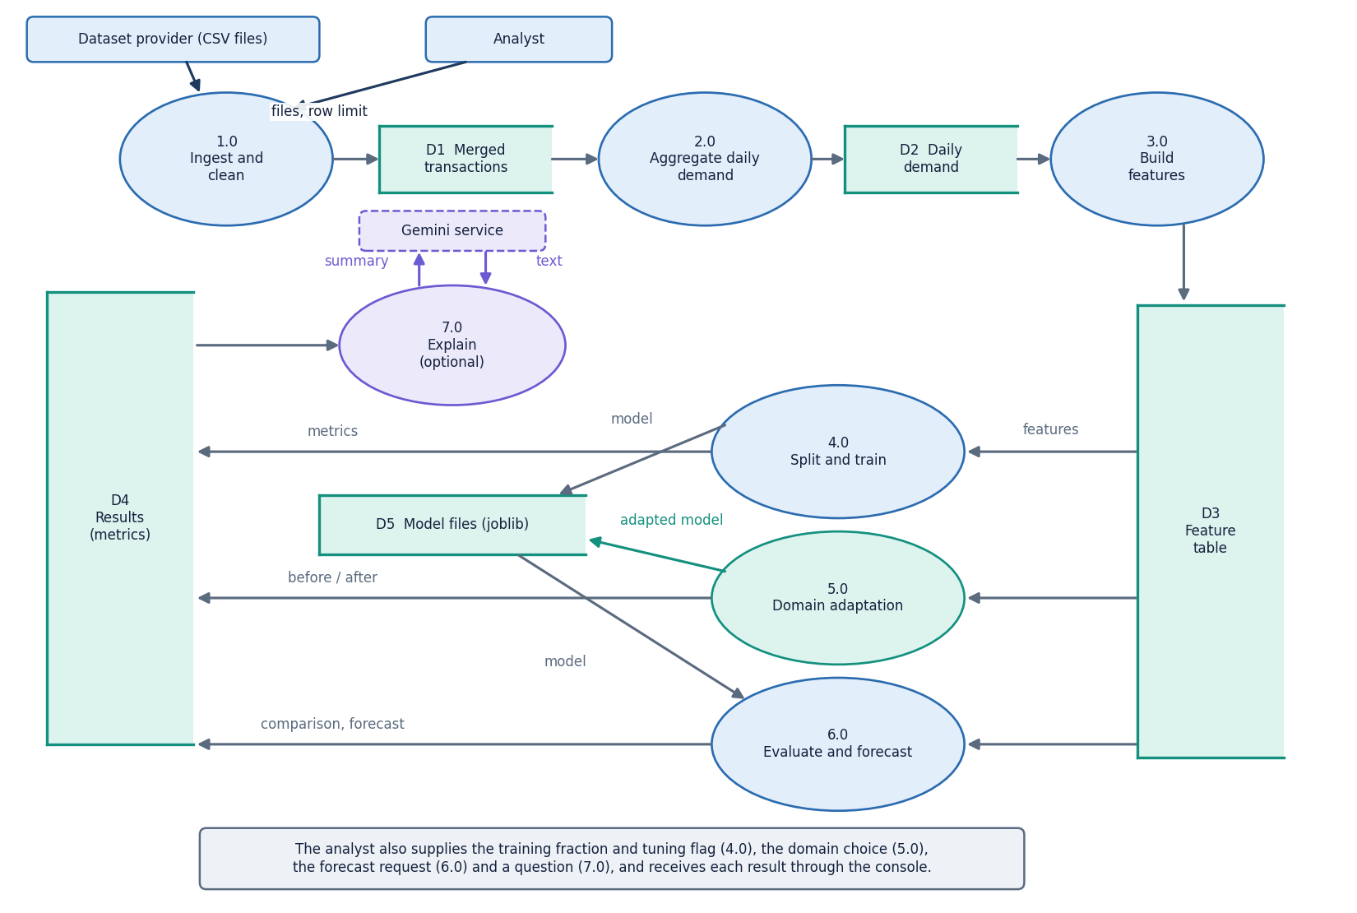
Figure 4: DFD level 1: seven processes (ingest, aggregate, features, train, adapt, evaluate and forecast, explain) and the data stores.
Level 1 shows the seven processes and four data stores. 1.0 Ingest validates the columns and writes the cleaned and merged tables (D1). 2.0 Aggregate writes the daily demand table (D2). 3.0 Build features writes the feature table (D3) and the category-code mappings. 4.0 Train reads D3 and writes the models (D5, joblib files). 5.0 Adapt reads D3 and writes the adapted model and the domain result. 6.0 Evaluate and forecast reads D3, D5 and the results store (D4). 7.0 Explain builds the aggregated context and calls Gemini. All stores except D5 are memory structures and are lost when the server stops.

1.3.3 Level 2: domain adaptation
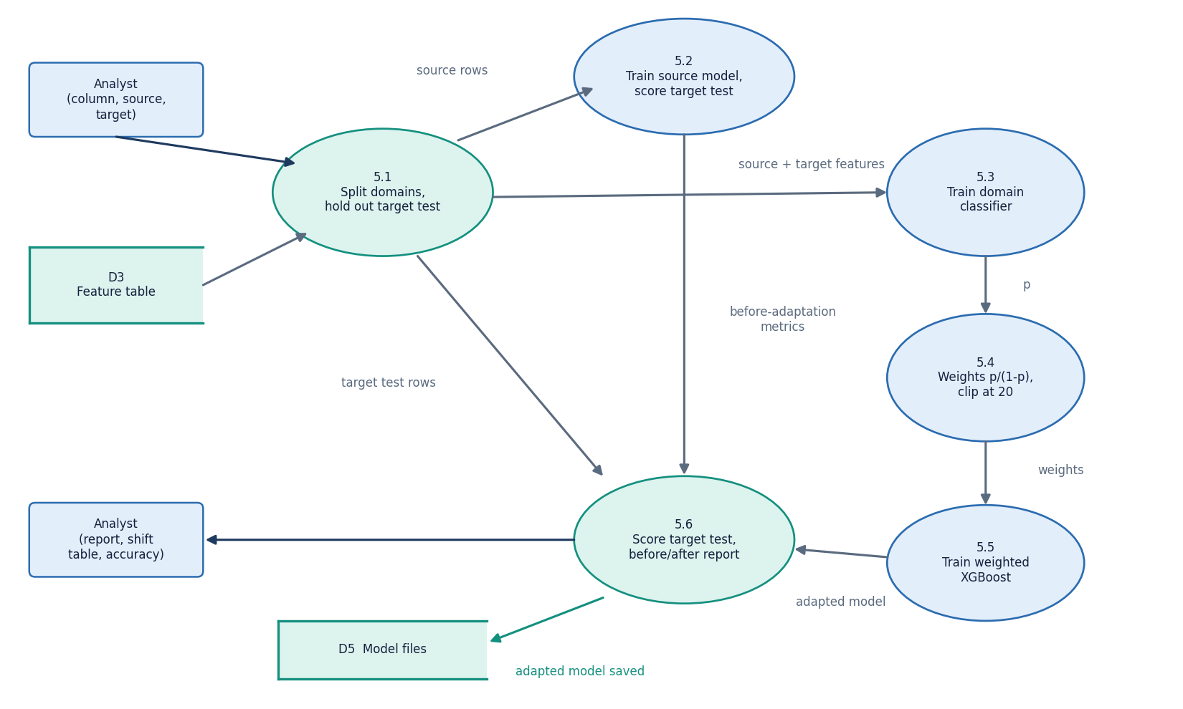
Figure 5: DFD level 2: the domain-adaptation process 5.0 expanded into six sub-processes.
Domain adaptation is the part of the product the project title names, so it is expanded to level 2. Six sub-processes take the feature table to a before-and-after report. Two design points matter. The domain column itself is removed from the model inputs, so neither the source model nor the classifier can read the answer off a feature. And the held-out target test rows are the later half of the target dates; they are used only to score the two models, never to fit them or the classifier's weights.

1.4 UML design

1.4.1 Class diagram
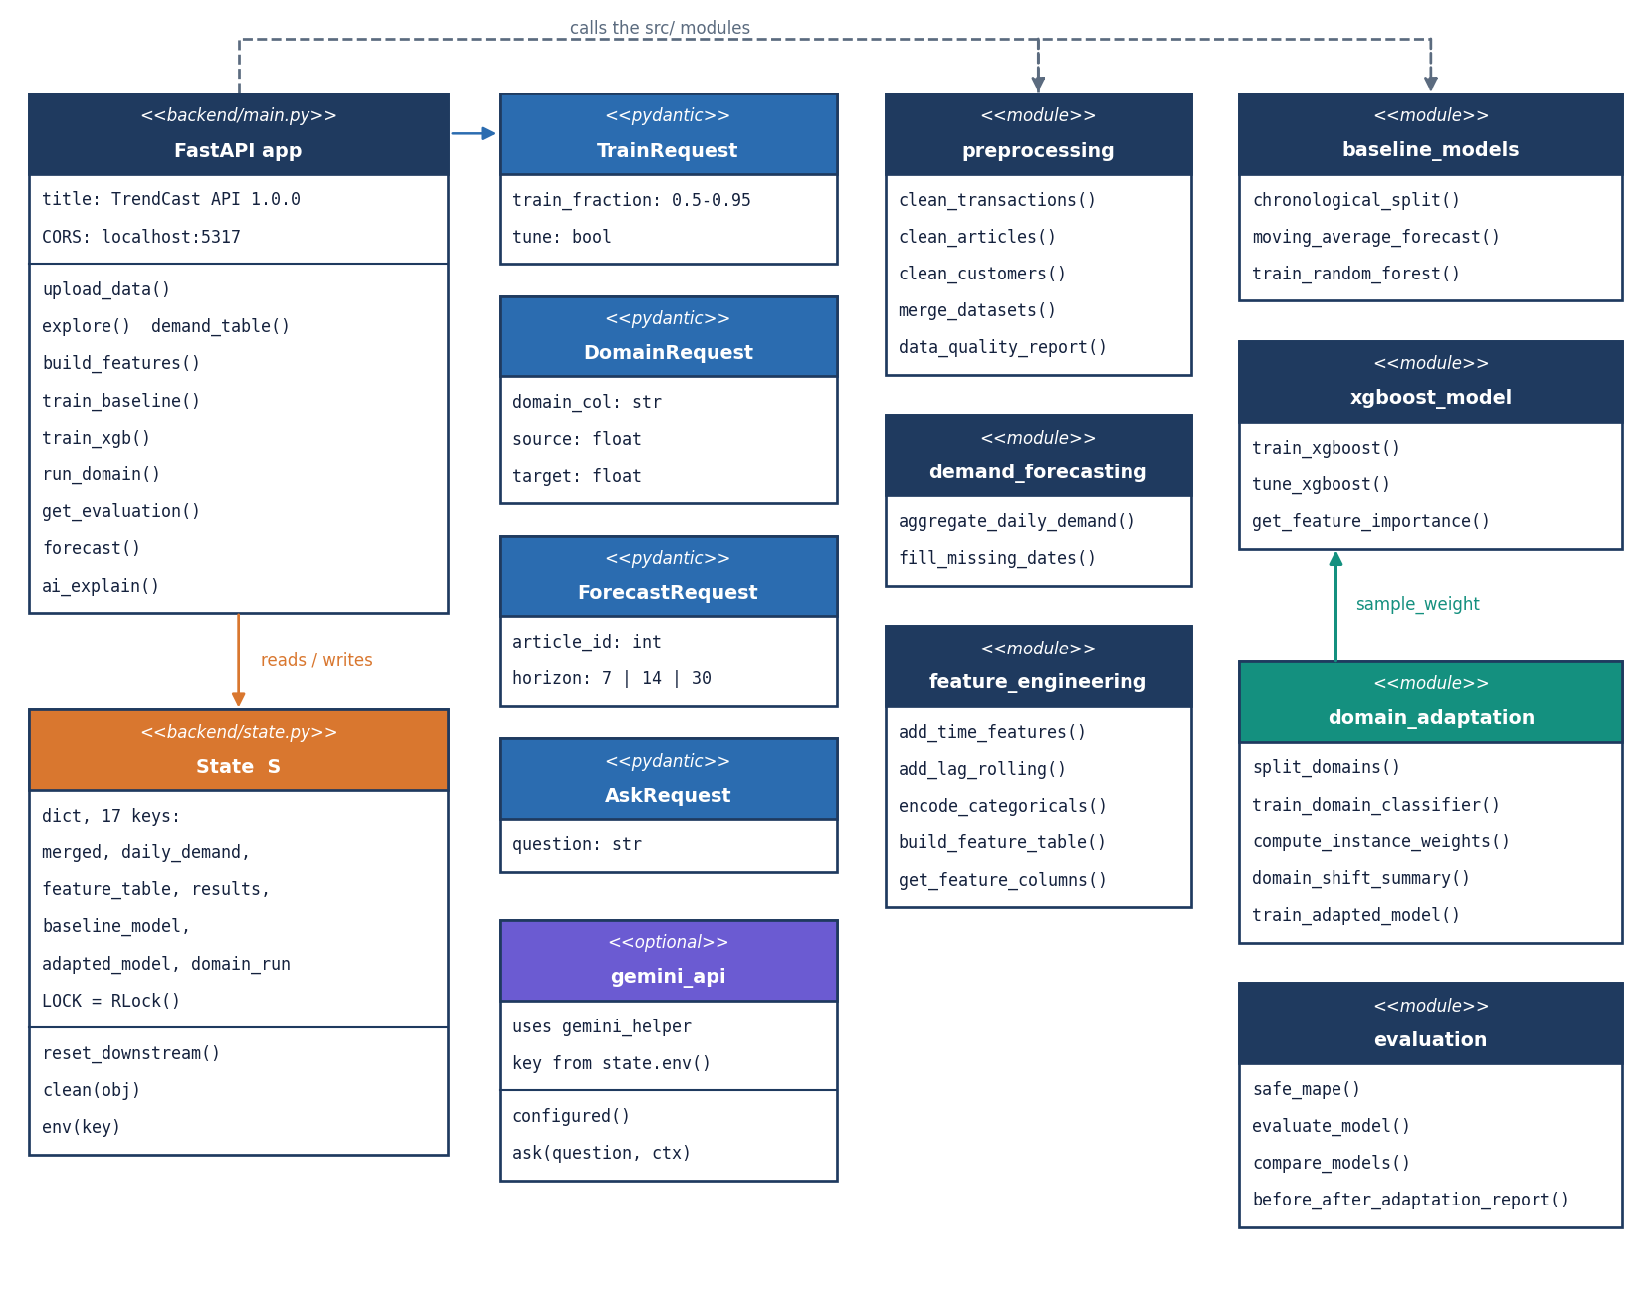
Figure 6: UML class diagram: the FastAPI application, request models, the shared state, and the src/ modules with their main functions.
The code base is organised as modules of functions rather than as classes, which suits a data pipeline in which each step takes a table and returns a table. The only classes are the four pydantic request models of the API, which validate input: TrainRequest (training fraction between 0.5 and 0.95, tuning flag), DomainRequest (column, source, target), ForecastRequest (article id, horizon) and AskRequest (question). The diagram draws each module as a class-like box so the dependencies are visible.
Table 2: Principal modules and the data they pass on.
Module | Takes | Returns
preprocessing | Raw transactions, articles, customers | Cleaned and merged transactions; quality report
demand_forecasting | Merged transactions | Daily demand table; zero-filled table
feature_engineering | Zero-filled daily table | Feature table and category mappings
baseline_models / xgboost_model | Feature table, train fraction, optional weights | Predictions, models, importance
domain_adaptation | Feature table, domain column and values | Source and target rows, classifier, weights, shift table, weighted model
evaluation | Actual and predicted demand | Metric dictionary, comparison and before-and-after tables

1.4.2 Sequence diagram
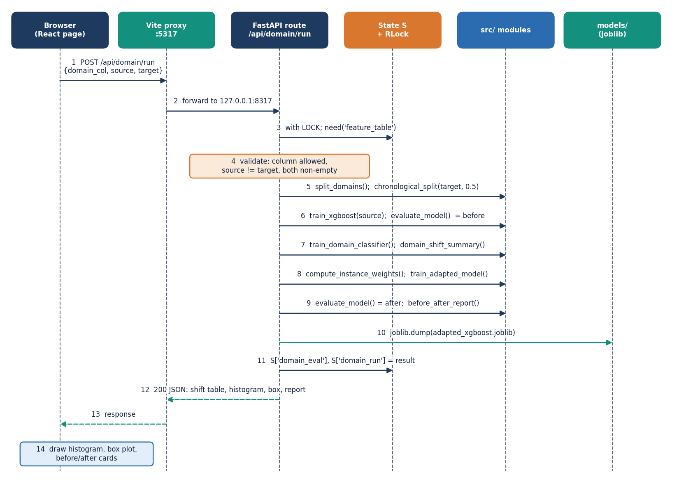
Figure 7: Sequence diagram: running domain adaptation from the browser, from the click to the before-and-after report.
The sequence follows POST /api/domain/run. The route takes the lock, checks the prerequisites (409 when the feature table is missing, 400 for an unknown column or equal values) and then runs six steps from the src/ package. It stores the result in S, writes the adapted model to models/adapted_xgboost.joblib and returns a JSON document that the page draws as the shift histogram, the box plot and four before-and-after cards. Holding the lock for the whole run serialises requests, which is what keeps the shared state consistent; the measured run takes about 3.7 s on the real subset, so the wait is short.

1.4.3 Use-case diagram
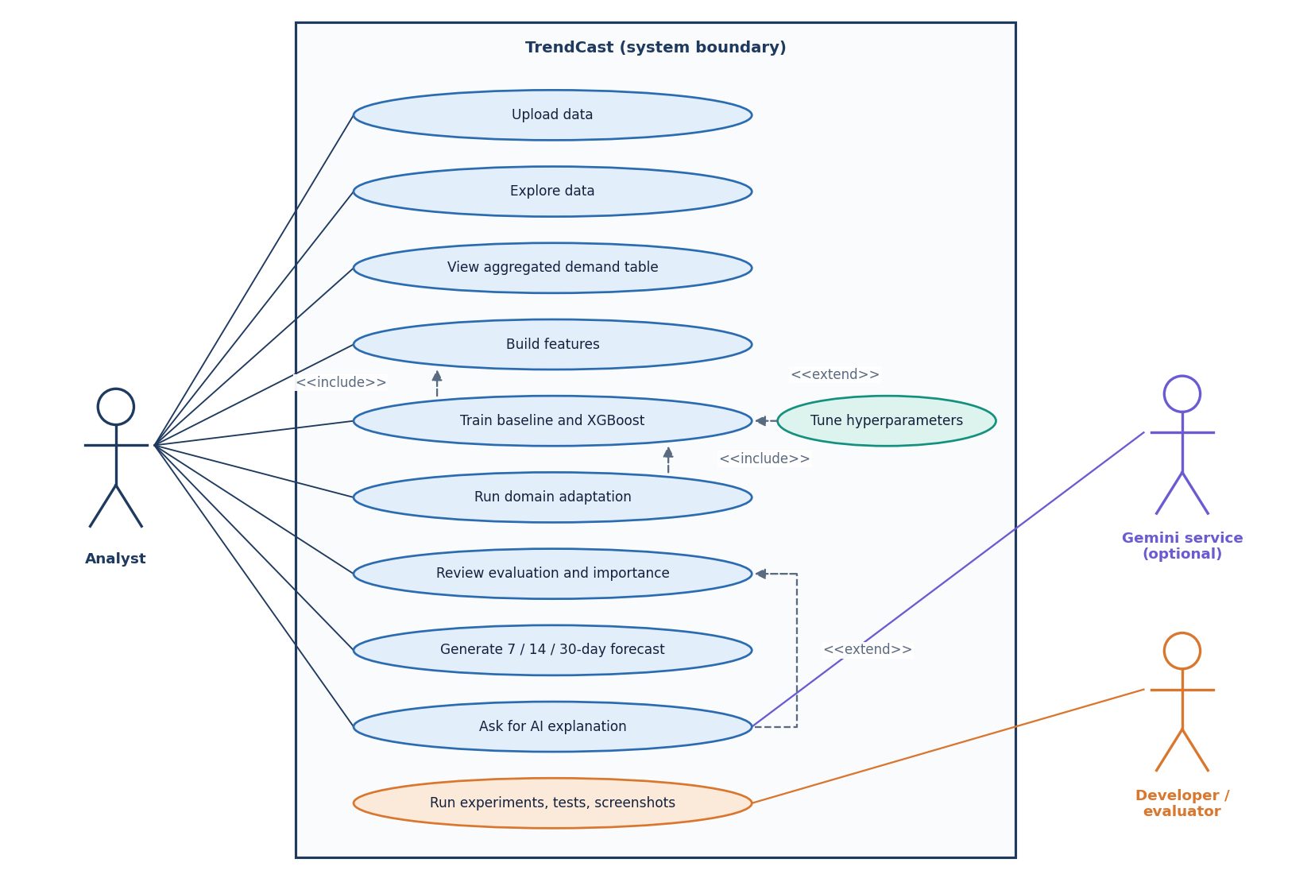
Figure 8: Use-case diagram with the analyst, the optional Gemini service and the developer or evaluator.
The analyst is the only human actor. Training includes building features and domain adaptation includes training the source model, so those relations are drawn as inclusions. The AI explanation extends evaluation and depends on the external Gemini service. The developer or evaluator is drawn at the edge because running the experiment, test and screenshot scripts is not part of the product but exercises the same package.

1.5 Database and state design
TrendCast has no database. Section 5.1 gave the reason; this section records what takes its place so that the design is complete.
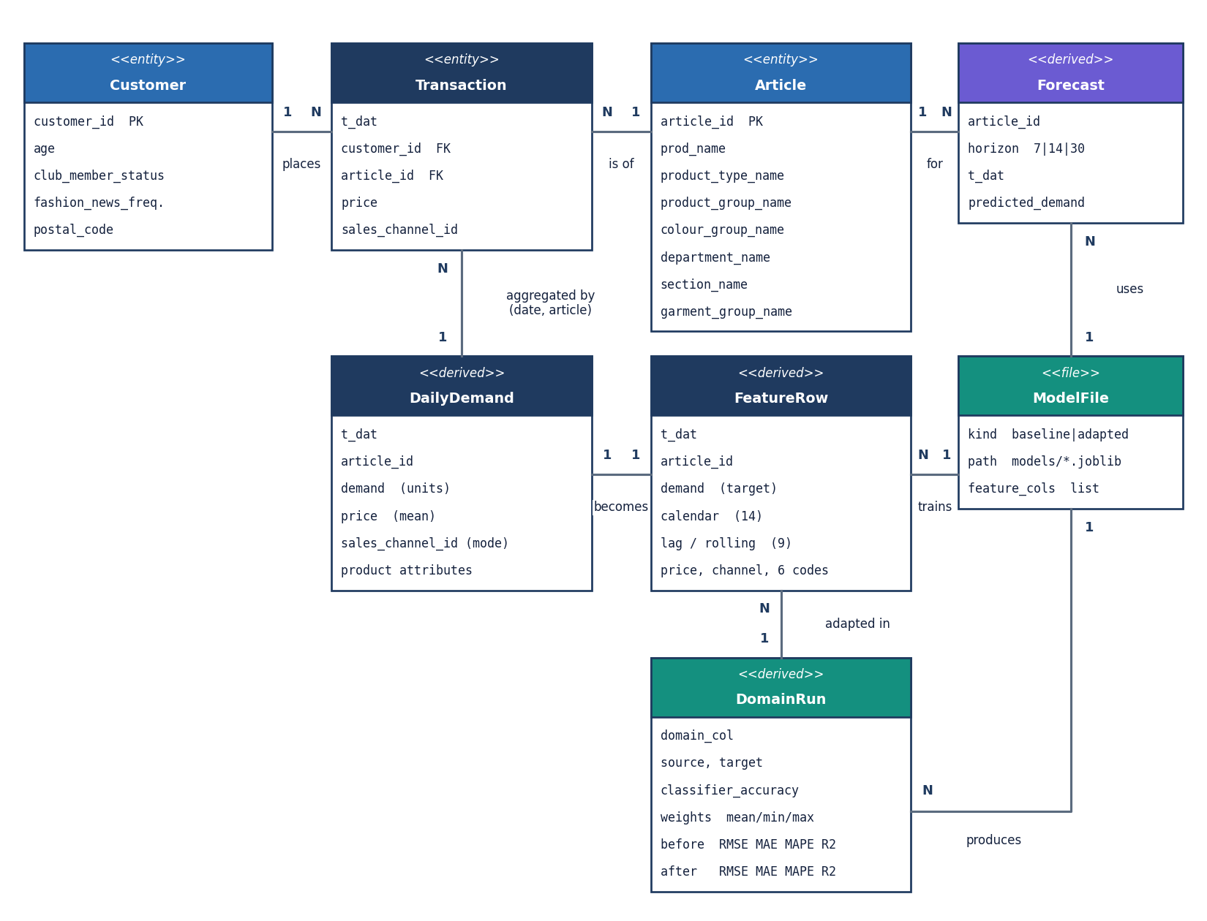
Figure 9: Logical entity-relationship diagram: TrendCast has no database; the entities are the uploaded tables, derived tables and model files.
The logical entities are the uploaded tables and the tables derived from them. A transaction row has the date, customer id, article id, price and sales channel. An article carries the product name and eight descriptive attributes (type, group, colour, department, section, garment group, index name and index group name) plus a free-text description. A customer row (optional) has age, club status and a postal code that the pipeline does not use. Aggregating by date and article gives the daily demand row: the count of transactions is the demand, the price is the mean of the day and the channel is the most frequent channel of the day. Each daily row becomes one feature row. A training run produces a model file, a domain run an adapted model and a result record, and a forecast a set of dated rows.
Table 3: The shared pipeline state S (backend/state.py) and what each key holds.
Key | Holds | Reset by
transactions_raw, articles_raw, customers_raw | The cleaned tables (the names say _raw but upload stores the cleaned versions) | Upload
merged, quality_report | Merged transactions and the data-quality report | Upload
daily_demand | Aggregated daily demand, built on first use | Upload
feature_table, feature_mappings | Feature table and integer-to-label maps for the six encoded attributes | Upload, rebuild
train_df, test_df | The last chronological split | Rebuild
baseline_model, source_model, adapted_model | Trained XGBoost objects | Upload, rebuild
domain_eval, domain_run | Before-and-after metrics and the full domain result | Upload, rebuild
results | Metric dictionaries keyed by model name | Upload, rebuild
last_forecast | The latest forecast table (read by the AI summary) | Upload, rebuild

Three files persist across restarts: models/baseline_xgboost.joblib, models/adapted_xgboost.joblib and models/feature_info.joblib, which stores the ordered list of feature columns so a loaded model can be used with a rebuilt table. The models/ and data/ folders are git-ignored. A new upload calls reset_downstream, so a model trained on old data can never be shown next to new data.

1.6 Core algorithm design
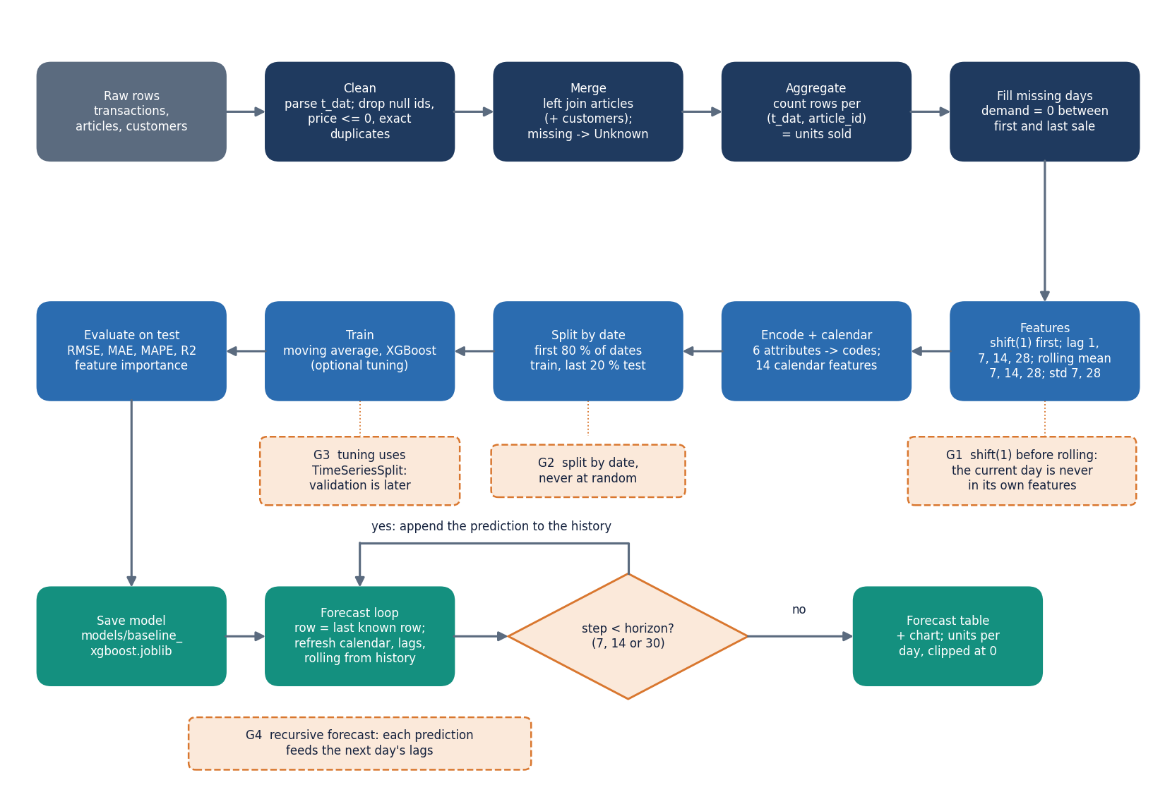
Figure 10: Flowchart of the core algorithm: from raw transactions to the recursive forecast, with the leakage guards marked.
The core algorithm is a sequence of table transformations with three leakage guards: the shifted lag and rolling features, the date-based split and the TimeSeriesSplit folds used when tuning. It ends in a recursive forecast: each predicted day is appended to the history so that the next day's lag and rolling features can be computed. A design consequence, documented honestly in Chapter 8, is that errors compound along the horizon. The forecast also reuses the last observed price and sales channel, and refreshes only the calendar features the route updates (year, month, day, weekday, weekend and the sine and cosine encodings).
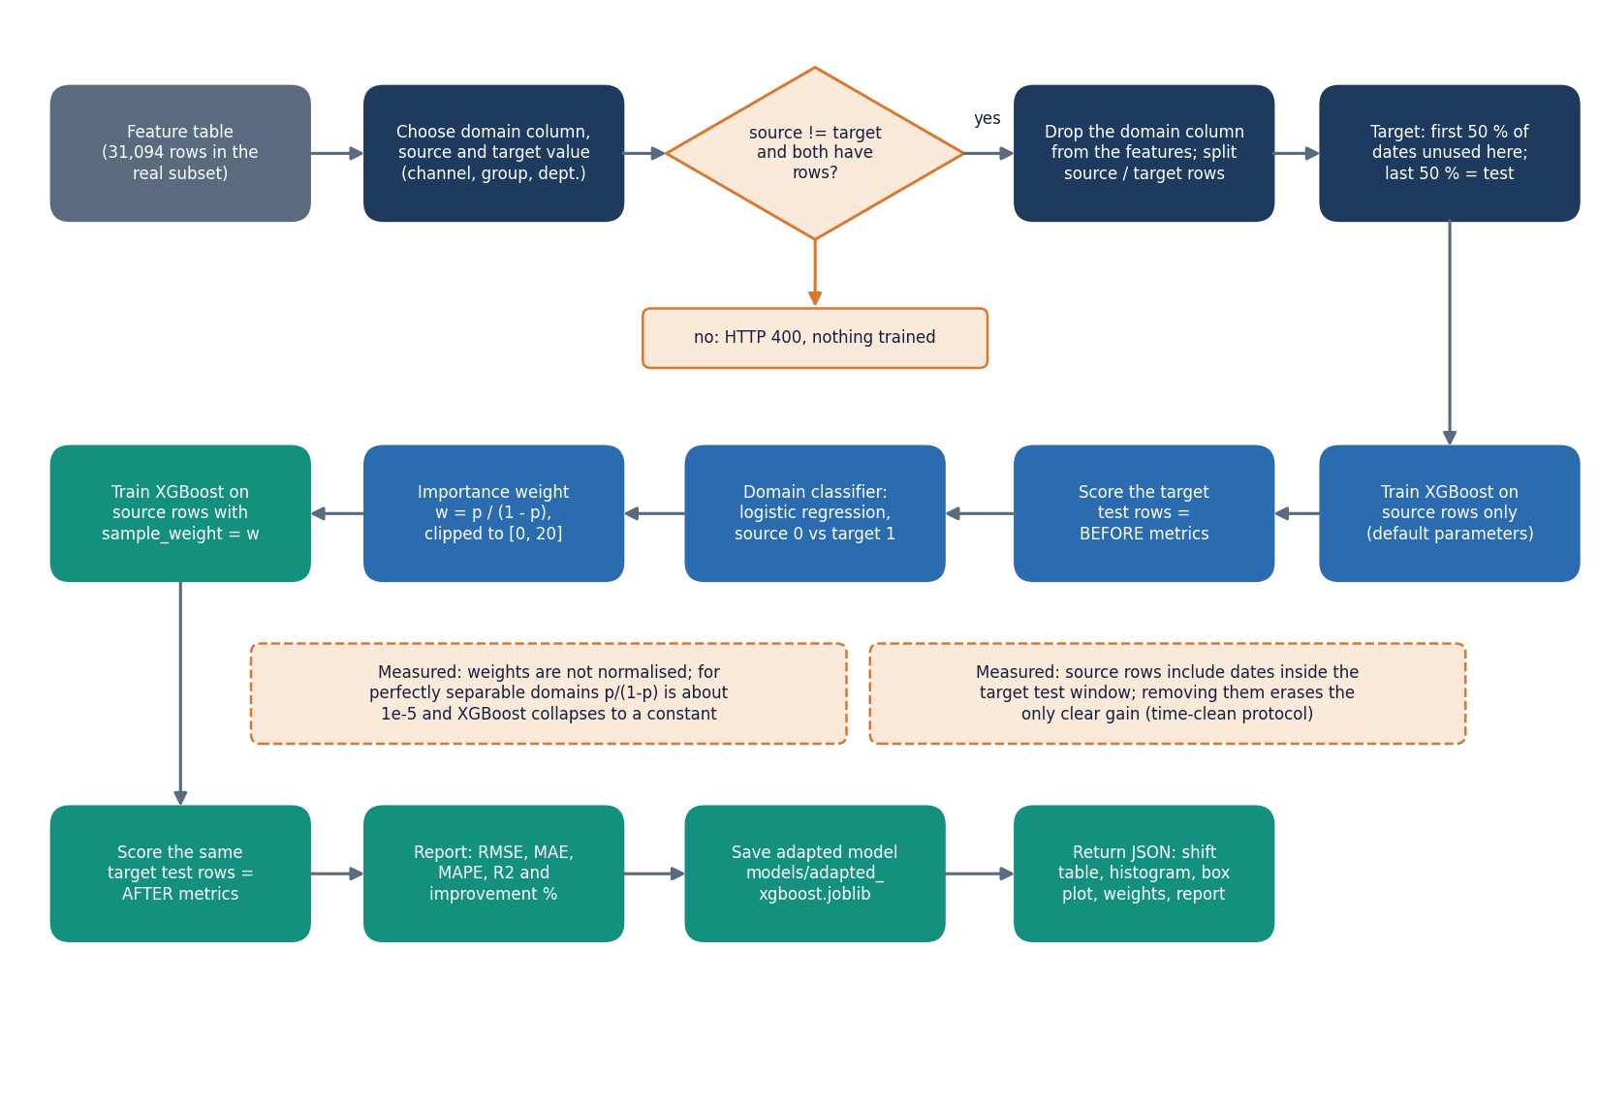
Figure 11: Flowchart of importance-weighted domain adaptation as implemented in domain_adaptation.py and the /api/domain/run route.
The domain-adaptation flowchart shows the procedure of Section 6.8. The design decision to clip the weights at 20 protects the weighted loss from a few extreme rows. The decision not to rescale the weights to a mean of one is simple to state and turned out to matter; Chapter 8 reports what happened when the two domains were perfectly separable. The idea follows covariate-shift correction by importance weighting [10], [12], with the logistic classifier standing in for a direct density-ratio estimate.
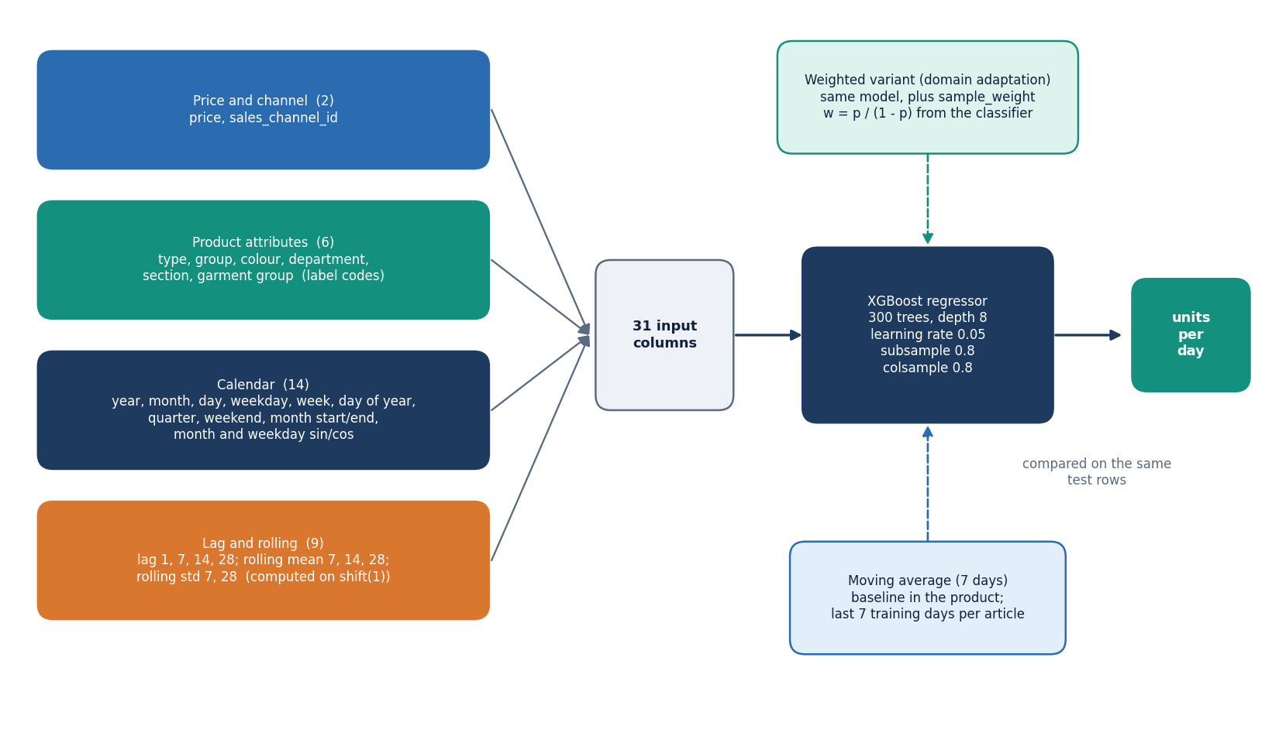
Figure 12: Model architecture: 31 input features in four groups feeding one XGBoost regressor, with the baselines and the weighted variant.
The model itself is a single regressor. The 31 inputs fall into four groups (price and channel, six encoded attributes, fourteen calendar features, nine lag and rolling features), and the weighted variant differs only in the per-row sample weights passed to fit. Keeping the adapted model identical in structure to the source model is intentional: any difference in the results can then be attributed to the weights.

1.7 Module design
The code is split so that each file has one reason to change. Line counts below were measured from the repository.
Table 4: Modules, sizes and responsibilities.
Module | Lines | Responsibility
src/data_loader.py | 104 | Required-column lists and the friendly DataValidationError; Streamlit upload helpers (the API reuses only the validators)
src/preprocessing.py | 135 | Clean transactions, articles and customers; left-join; data-quality report
src/demand_forecasting.py | 121 | Aggregate to units per article per day; zero-fill the missing days
src/feature_engineering.py | 165 | Calendar, cyclical, lag and rolling features; label encoding; feature-column selection
src/baseline_models.py | 106 | Chronological split, moving average, random forest, LightGBM
src/xgboost_model.py | 95 | XGBoost with optional sample weights; TimeSeriesSplit random search; importance
src/domain_adaptation.py | 141 | Domain split, logistic domain classifier, importance weights, shift table, weighted model
src/evaluation.py | 117 | RMSE, MAE, safe MAPE, R2, comparison table, before-and-after report
src/visualization.py | 119 | Plotly figures for the Streamlit app
src/gemini_helper.py | 119 | Builds the aggregated, raw-data-free context for AI Insights
backend/main.py | 626 | FastAPI application: 22 routes, request models, gating helpers
backend/state.py | 90 | Shared pipeline state S, lock, model paths, .env reader, JSON cleaner
backend/gemini_api.py | 70 | REST call to Gemini with the key and model from .env
app.py | 597 | Original Streamlit application, 11 pages (kept unchanged)
frontend/src/ | 4,414 | React 19 console: 13 pages, UI kit, charts, API client and pipeline-progress context
tests/ | 390 | 39 pytest tests (22 unit, 17 API)

Three decisions about this structure are worth recording. The backend does not re-implement any pipeline step: the forecast loop is the one piece of logic that exists twice, because the Streamlit version is written inside a page function. The experiment script scripts/run_experiments.py imports the same src/ functions as the API, so the numbers in Chapter 8 come from the product's code, not from a parallel implementation. And the web console has its own small UI kit (buttons, cards, charts, tables, toasts), so the pages contain layout and calls, not styling.

1.8 API design
All routes live under /api. Reads are GET and actions are POST. Failures return the FastAPI detail string, which the console shows verbatim, so error messages are written for the analyst: 'Upload and process your data first (Data Upload).' is what a 409 says. The status codes follow one rule: 409 means an earlier step is missing, 400 means the request is well-formed but not acceptable, 422 means the request body failed validation, 404 means a saved model is absent, 502 and 503 are reserved for the optional AI service.
Table 5: The 22 routes of the TrendCast API.
Method | Path | Purpose | Errors
GET | /api/health | Liveness check | -
GET | /api/state | Nine progress flags (data_loaded, daily_ready, features_ready, baseline_ran, xgboost_trained, domain_done, forecast_done, saved_model_exists, gemini_configured) | -
POST | /api/data/upload | Multipart transactions, articles, optional customers and a row limit; cleans, merges, resets everything downstream; returns the quality report | 400 missing column / empty / unreadable file
GET | /api/data/report | The last data-quality report | 409 before upload
GET | /api/explore | Daily, monthly, weekly series, top-10 products, department, colour and channel totals, price histogram | 409
GET | /api/demand/table | First limit rows (1-2,000) of the daily demand table | 409
POST | /api/features/build | Zero-fill, build the 31-input feature table, clear models and results | 409
GET | /api/features | Shape, feature columns and the first 50 rows | 409
GET | /api/training/split | Date ranges and row counts for a training fraction | 400 if outside 0.5-0.95 or a side is empty; 409
POST | /api/training/baseline | Moving-average baseline on the chronological split | 422 bad fraction; 409
POST | /api/training/xgboost | Default or tuned XGBoost; saves the model and feature list | 422; 409
POST | /api/training/load | Loads the saved model from models/ | 404 if none saved
GET | /api/training/results | Model comparison rows | -
GET | /api/domain/options | Offered domain columns (channel, product group, department) and their values | 409
POST | /api/domain/run | Source model, domain classifier, shift table, weights, adapted model, before/after report | 400 same values, bad column, empty domain; 409
GET | /api/domain/last | Most recent domain run, so the page survives a reload | -
GET | /api/evaluation | Comparison table, domain report, top-20 gain importance | -
GET | /api/forecast/articles | Article ids with product type and total units | 409 until a model is trained
POST | /api/forecast | Recursive 7, 14 or 30-day forecast for one article with 60 days of history | 400 horizon or < 5 days of history; 409
GET | /api/ai/status | Whether a Gemini key is configured and the model name | -
POST | /api/ai/explain | Plain-language answer built from aggregated metrics, importance and domain-shift numbers | 503 not configured; 502 service error
POST | /api/ai/forecast-summary | Two-to-three-sentence summary of the latest forecast | 409; 503; 502

POST /api/data/upload is the only multipart route. It accepts a row limit because the full H&M transactions file has 31.8 million rows; a value of 0 means no limit. The limit reads the first rows of the file, which are the earliest dates, so a small limit gives a short date range rather than a random sample. POST /api/forecast accepts only the horizons 7, 14 and 30 and needs at least five days of history for the article.

1.9 User interface design
The console has thirteen pages: a public landing page, an about page, an overview that shows pipeline progress, seven working pages (upload, explore, demand, features, training, domain, evaluation, forecast), the AI insights page and a not-found page. The visual language is a flat, high-contrast grid with thick borders and one accent colour per state, which keeps charts and tables legible and prints well. A light and a dark theme are available from every page.
Table 6: Console pages and the endpoints they use.
Page | Route | Endpoints used
Landing, About | / and /about | None (public)
Overview | /app | /api/state
Data upload | /app/upload | POST /api/data/upload, GET /api/data/report
Data exploration | /app/explore | GET /api/explore
Demand analysis | /app/demand | GET /api/demand/table
Feature engineering | /app/features | POST /api/features/build, GET /api/features
Model training | /app/training | /api/training/split, baseline, xgboost, load, results
Domain adaptation | /app/domain | /api/domain/options, run, last
Model evaluation | /app/evaluation | GET /api/evaluation
Demand forecast | /app/forecast | /api/forecast/articles, POST /api/forecast
AI insights | /app/insights | /api/ai/status, explain, forecast-summary

Four design rules were applied to every working page. Each page opens with its purpose and the step it belongs to. Long actions show a busy state and finish with a notice. Numbers are formatted the same way everywhere (thousands separators, three decimals for errors, a percentage for MAPE) and a result that is worse than the baseline is drawn in the warning colour with the word 'worse', not hidden. Errors from the API are shown in a panel with a retry button. Chapter 8 shows each working page with real data; the three screens below illustrate the design itself.
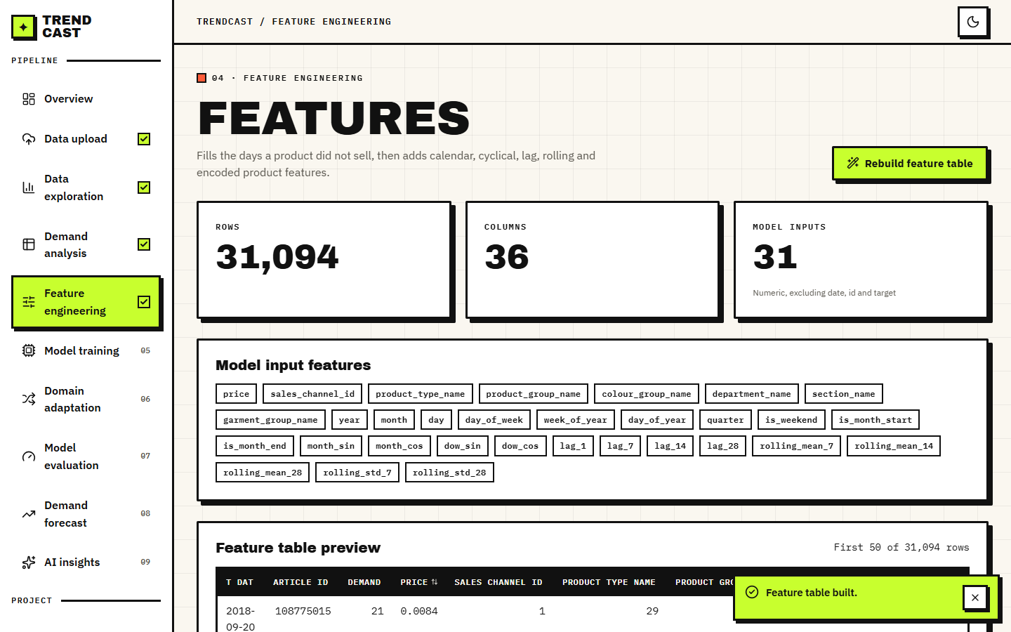
Figure 13: Feature-engineering page after building the table: 31,094 rows, 36 columns, 31 model inputs.
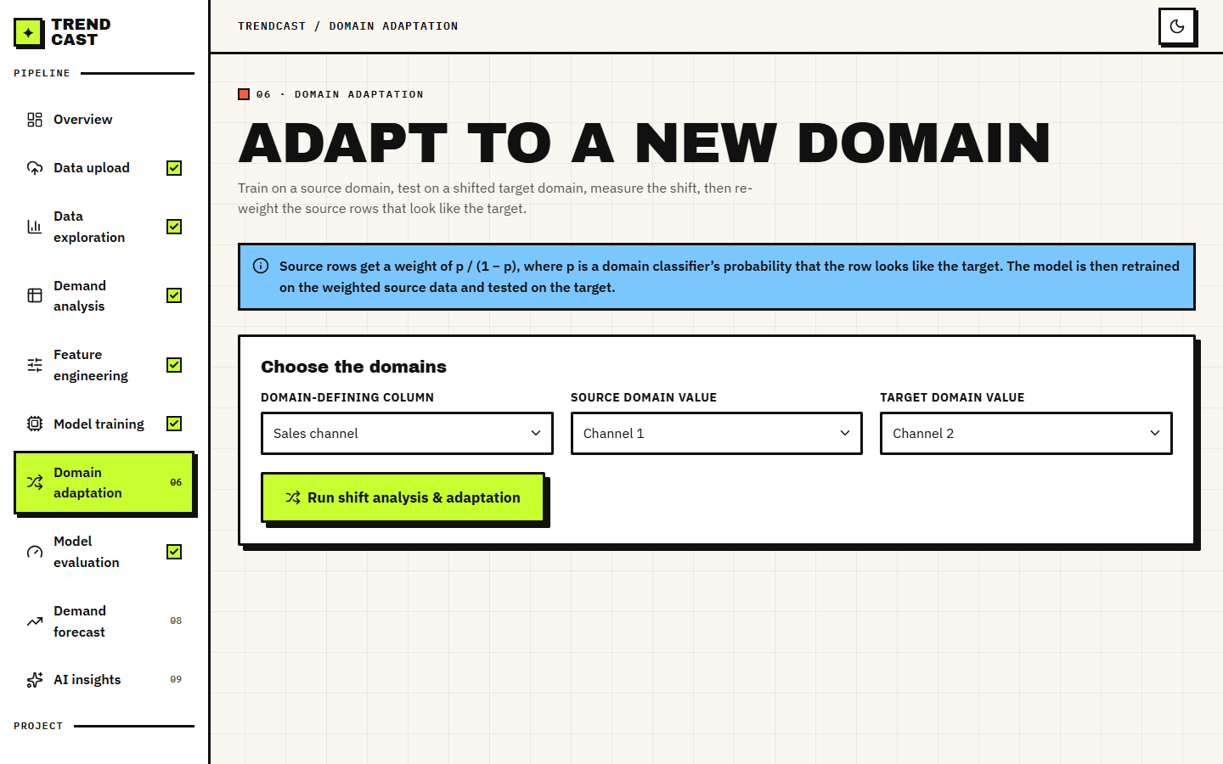
Figure 14: Domain-adaptation page: the analyst chooses the domain-defining column and the source and target values before running.
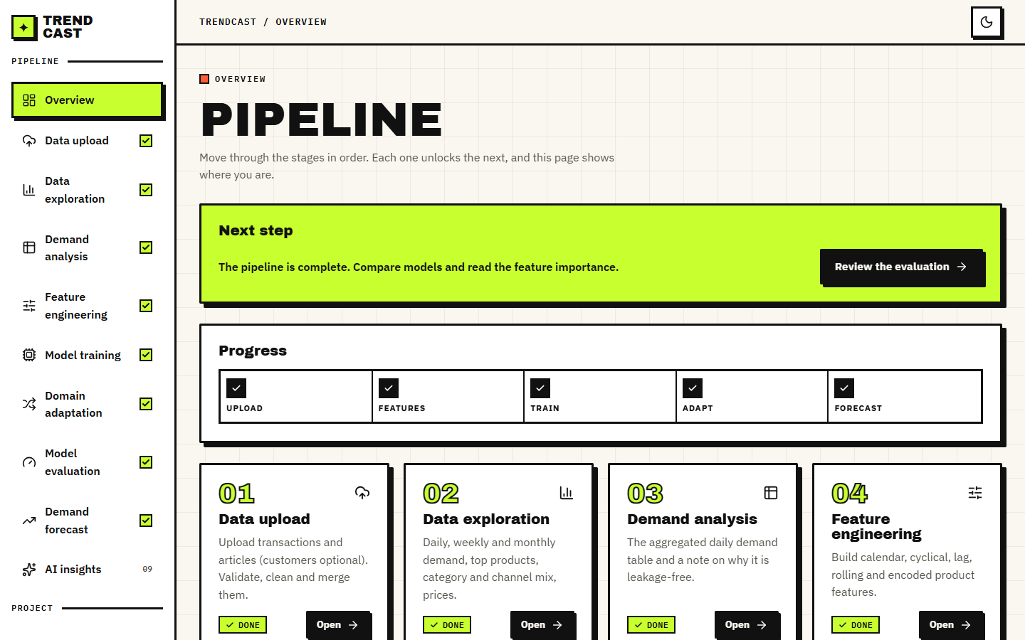
Figure 15: Overview page: the pipeline progress is read from the server, with the next step highlighted.

1.10 Design decisions and trade-offs
Every design has costs. The table records the main decisions, what each bought and what it cost, so that the limitations in Chapter 9 can be traced back to a choice and not to an accident.
Table 7: Principal design decisions.
Decision | Reason | Cost
Keep the ML code in src/ and wrap it with a thin API | One implementation for both front ends; experiments and tests call the product's own functions | Two src/ modules still import Streamlit, and the forecast loop exists twice
Hold all state in one in-memory dictionary | No database to install; a new upload cleanly invalidates everything derived from the old one | Single user only; everything except the model files is lost on restart
Split by date, never randomly | A random split would let the model see the future and give optimistic numbers | The test window may contain events (here Christmas) the training window lacks
Importance weighting for domain adaptation | Simple, inspectable, works with any learner that takes sample weights | Depends on a well-behaved classifier; weights are unnormalised (Chapter 8)
Gate each page on the pipeline flags | No expected errors in the browser; the analyst is told the next step | Pages cannot be opened out of order
Report results as measured, including negative changes | The aim is to learn whether adaptation works, not to show that it does | The headline numbers are modest
Optional Gemini explanation with aggregated context only | Plain-language help without sending raw data; the app works without a key | Depends on an external service that was unavailable during our screen capture

Two further choices concern what was left out. Probabilistic forecasts, safety-stock calculation and per-forecast explanations were not built: the batch objectives mention explaining forecast drivers and translating error into inventory impact, but the product offers gain-based importance for the whole model only, and the inventory translation was done offline for Chapter 8. These are stated plainly as the gap between the objectives and the delivered design. Finally, the design does not include a cold-start path for articles without history: the forecast route needs five days of data per article and the lag features need more. Chapter 8 measures what an attribute-only model could do for unseen articles, and Chapter 10 proposes adding it.

2. IMPLEMENTATION

2.1 Application architecture
The product exists in two front ends over one pipeline. The Streamlit application (app.py, 597 lines, 11 pages) is the original and is left unchanged. The web application has a FastAPI back end (backend/main.py, port 8317) and a React 19 front end built with Vite (port 5317). Both import the same src/ modules, so a number computed in one is computed identically in the other.
Figure 16: Layered architecture of TrendCast: React console, Vite proxy, FastAPI application with 22 routes, the src/ pipeline modules, and in-memory state plus joblib model files.
The back end is organised around one idea: a route does only HTTP work. It checks that the required state exists (the helper need raises a 409 with an instruction), validates the request with a pydantic model, takes the lock, calls the src/ function, stores the result in the shared state S, and converts the result to JSON with clean, which turns NaN and infinity into null and dates into ISO strings so that the browser never receives invalid JSON. The helper below is the gate used by every downstream route.
def need(key: str, message: str):
"""Return S[key] or raise a 409 with a plain-language 'do this first' message."""
value = S.get(key)
if value is None or (isinstance(value, pd.DataFrame) and value.empty):
raise HTTPException(status_code=409, detail=message)
return value

The front end reads progress from /api/state through a context provider and renders each page inside a gate. Pages call the API through one fetch wrapper that turns FastAPI error details into readable messages and reports status 0 when the server cannot be reached ('Cannot reach the TrendCast API. Start the backend (run.bat) and retry.'). Charts use Recharts; the layout, theme toggle, toasts and tables come from a small in-house UI kit.

2.2 API design
Chapter 5 lists the 22 routes. This section shows the shape of the most important exchange, domain adaptation. The request is a three-field JSON document; the response carries everything the page draws, so the page makes one call and no further computation happens in the browser.
POST /api/domain/run
{ "domain_col": "sales_channel_id", "source": 1, "target": 2 }

200 OK
{ "source_label": "Channel 1", "target_label": "Channel 2",
"source_rows": 12240, "target_rows": 18854, "target_test_rows": 9890,
"classifier_accuracy": 0.663,
"shift": [ {"feature": "lag_1", "source_mean": ..., "target_mean": ..., "mean_diff": ...}, ... 15 rows ],
"top_shift_feature": "lag_1", "histogram": [...30 bins...], "box": {...},
"weights": {"mean": 1.58, "max": 20.0, "min": 0.10},
"before": {"RMSE": 18.983, ...}, "after": {"RMSE": 18.989, ...},
"report": [ {"Metric": "RMSE", "Before Adaptation": ..., "After Adaptation": ..., "Improvement (%)": ...}, ... ] }

The values shown are those of the capture run on the real subset: the adapted model's RMSE (18.989) is marginally worse than the source model's (18.983), and the interface labels that as '0.0 % worse' instead of rounding it into a success. The forecast route follows the same pattern: the request is {article_id, horizon} and the response holds the last 60 days of history, the forecast rows, their sum and the number of history days used.
Measured behaviour (real subset, 127.0.0.1, other jobs running on the same machine): upload, clean and merge 3.5 s; daily aggregation 2.7 s; feature building 0.9 s; default XGBoost 1.1 s; tuned XGBoost 29.6 s; domain adaptation 3.7 s. Median latency of the forecast route over 20 calls is 45 ms (7 days), 75 ms (14 days) and 156 ms (30 days); the lightweight routes answer in about 3 ms. The forecast time grows linearly with the horizon because each day is one model call.
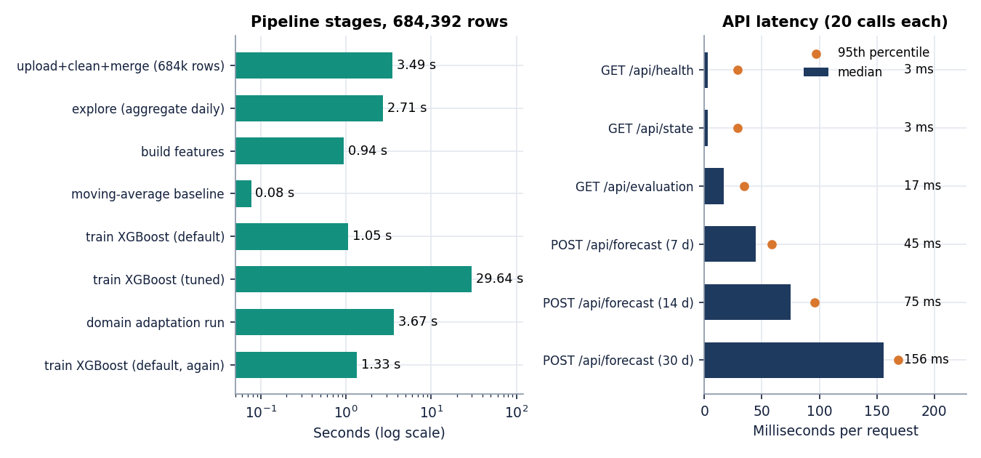
Figure 17: Measured pipeline stage times and median endpoint latency (real H&M subset, 127.0.0.1).

2.3 Security and error handling
TrendCast is a single-user analysis tool and its security model is correspondingly simple. We list what exists and what does not, so that nobody assumes more.
• No authentication or accounts. Anyone who can reach port 8317 can use the tool and read the shared state. This is acceptable on a student's machine and unacceptable on a server; it is listed in Chapter 9.
• CORS allows only http://localhost:5317 and http://127.0.0.1:5317, so a page from another origin cannot call the API from a browser.
• Input validation. Uploads must contain the required columns (t_dat, customer_id, article_id, price for transactions; article_id, prod_name for articles) or the route answers 400 with the missing names; empty and unreadable files answer 400; the training fraction is limited to 0.5-0.95 by the request model; the horizon must be 7, 14 or 30; the domain column must be one of three offered names.
• Secrets. The Gemini key is read from .env, which is git-ignored (and .streamlit/secrets.toml for the Streamlit app). The repository contains only .env.example. .env.example also lists DATABASE_URL and JWT_SECRET, which this code does not use because there is neither a database nor a login.
• Data sent to the outside. Only the optional AI Insights route contacts an external service. Its context is built by gemini_helper.build_context_summary from the metric dictionary, the top ten feature importances, the domain-shift summary and a forecast summary; raw rows are never included. The prompt tells the model to use only that data.
• Failure behaviour. Missing prerequisites answer 409 and a missing saved model 404. If Gemini is not configured the route answers 503; if the call fails or times out the route answers 502 with a message that every other page still works. During our screenshot run the service answered 503 ('high demand') and later timed out; the page showed the message and nothing else broke.
• Concurrency. A re-entrant lock serialises routes that read or change the pipeline tables, so two requests cannot interleave a split or a model assignment. The state itself is global, so two users share it.
The automated tests cover the gating, the validation messages, the reset-on-upload rule and the AI-not-configured path (Chapter 7).

2.4 Installation and execution
The project needs Python 3.10 or newer and Node.js 18 or newer. requirements.txt lists streamlit, pandas, numpy, scikit-learn, xgboost, lightgbm, plotly, joblib, python-dateutil, google-generativeai, fastapi, uvicorn, python-multipart and requests. Measurements in this report were taken with Python 3.11.9, scikit-learn 1.5.0, XGBoost 2.0.3, LightGBM 4.7.0, pandas 2.2.1 and NumPy 1.26.4 (LightGBM was installed only for the baseline comparison).
1. Open the project folder 8.ProjectCode. Copy .env.example to .env; ports 8317 and 5317 are preset, and the Gemini key is optional.
2. Run run.bat. It reads the ports from .env, creates .venv if it is absent, installs requirements.txt once (a marker file avoids repeating it), runs npm install in frontend/ if needed, starts the back end with uvicorn and the front end with Vite in two console windows, and opens the browser at http://localhost:5317.
3. Open Data upload, choose the transactions and articles CSV (customers optional), set the row limit (0 means no limit) and press 'Load & process data'. Then follow the pages in order; each one tells you if a step is missing.
4. To check the installation run run.bat test: it starts the back end, creates the synthetic sample if needed and runs scripts/smoke_test.py (26 checks). python -m pytest tests -q runs the 39 unit and API tests.
5. To use the original Streamlit application instead, run streamlit run app.py; to rebuild the real-data subset, run scripts/make_real_subset.py on the downloaded H&M files.
Appendix B gives the same instructions as a user guide with the screens. Two practical notes: a fresh environment may install newer package versions than those listed above, which is why the scikit-learn and XGBoost versions are recorded; and the first start of run.bat takes several minutes because of the package downloads.

3. KEY CODE WALK-THROUGHS

3.1 Leakage-safe lag and rolling features (`feature_engineering.py`)
The strongest predictor of tomorrow's demand is recent demand, so the main risk is a feature that quietly contains today's value. Lags use shift(n) per article. Rolling statistics are computed on a series that has already been shifted by one day, so a window of seven days ends yesterday. Rows at the start of an article's history, which lack a full window, are filled with zero.
# inside add_lag_rolling_features(df, group_col, date_col, target_col)
out = df.sort_values([group_col, date_col]).copy()
grouped_target = out.groupby(group_col)[target_col]

for lag in LAG_DAYS:
out[f"lag_{lag}"] = grouped_target.shift(lag)

# shift(1) first so the rolling window never includes today's demand
shifted = out.groupby(group_col)[target_col].shift(1)
out["_shifted_demand"] = shifted

for window in ROLLING_MEAN_WINDOWS:
out[f"rolling_mean_{window}"] = (
out.groupby(group_col)["_shifted_demand"]
.transform(lambda s: s.rolling(window, min_periods=1).mean())
)

for window in ROLLING_STD_WINDOWS:
out[f"rolling_std_{window}"] = (
out.groupby(group_col)["_shifted_demand"]
.transform(lambda s: s.rolling(window, min_periods=1).std())
)

out = out.drop(columns=["_shifted_demand"])

3.2 Importance weights (`domain_adaptation.py`)
The domain classifier is a logistic regression trained on source rows (label 0) and target rows (label 1) with the model's own features. Each source row then receives the odds that it looks like a target row. The ratio is clipped at 20 so a few rows cannot dominate the loss, but nothing stops it from becoming tiny, which is the defect found in Chapter 8.
def train_domain_classifier(
source_features: pd.DataFrame, target_features: pd.DataFrame
) -> tuple[LogisticRegression, float]:
X = pd.concat([source_features, target_features], axis=0)
y = np.array([0] * len(source_features) + [1] * len(target_features))

X_train, X_test, y_train, y_test = train_test_split(
X, y, test_size=0.25, random_state=42, stratify=y
)

clf = LogisticRegression(max_iter=1000)
clf.fit(X_train, y_train)

acc = accuracy_score(y_test, clf.predict(X_test))
return clf, acc

def compute_instance_weights(
domain_classifier: LogisticRegression, source_features: pd.DataFrame, clip_max: float = 20.0
) -> np.ndarray:
p_target = domain_classifier.predict_proba(source_features)[:, 1]
p_target = np.clip(p_target, 1e-6, 1 - 1e-6) # avoid divide-by-zero
weights = p_target / (1 - p_target)
weights = np.clip(weights, 0, clip_max)
return weights

3.3 Domain run (`backend/main.py`, route `/api/domain/run`)
The domain column is removed from the features so the classifier cannot read its own label. The later half of the target dates is held out as the test set; the source model trains on all source rows, which is why source dates can overlap the target test window. The same held-out rows score the model before and after weighting.
cols = [c for c in feature_cols_of(ft) if c != req.domain_col]
source_df, target_df = domain_adaptation.split_domains(ft, req.domain_col, req.source, req.target)
if source_df.empty or target_df.empty:
raise HTTPException(status_code=400, detail="One of the domains has no data. Choose different values.")

source_X, source_y = source_df[cols], source_df["demand"]
target_train, target_test = baseline_models.chronological_split(target_df, train_fraction=0.5)
if target_test.empty or target_train.empty:
raise HTTPException(status_code=400, detail="The target domain has too few dates to hold out a test half. Choose a larger target domain.")
target_test_X, target_test_y = target_test[cols], target_test["demand"]
...
source_model = xgboost_model.train_xgboost(source_X, source_y)
metrics_before = evaluation.evaluate_model(target_test_y, source_model.predict(target_test_X))

classifier, acc = domain_adaptation.train_domain_classifier(source_X, target_df[cols])
shift = domain_adaptation.domain_shift_summary(source_X, target_df[cols])
top_feature = shift.iloc[0]["feature"]

weights = domain_adaptation.compute_instance_weights(classifier, source_X)
adapted = domain_adaptation.train_adapted_model(source_X, source_y, weights)
metrics_after = evaluation.evaluate_model(target_test_y, adapted.predict(target_test_X))

3.4 Recursive forecast (`backend/main.py`, route `/api/forecast`)
Each predicted day is appended to the history so that the next day's lags and rolling statistics are built from predictions. Only some calendar columns are refreshed; price and channel stay at the last observed values, and the prediction is clipped at zero.
for step in range(1, req.horizon + 1):
future_date = last_date + pd.Timedelta(days=step)
row = last_row.copy()
row["t_dat"] = future_date

row["year"] = future_date.year
row["month"] = future_date.month
row["day"] = future_date.day
row["day_of_week"] = future_date.dayofweek
row["is_weekend"] = int(future_date.dayofweek >= 5)
row["month_sin"] = np.sin(2 * np.pi * future_date.month / 12)
row["month_cos"] = np.cos(2 * np.pi * future_date.month / 12)
row["dow_sin"] = np.sin(2 * np.pi * future_date.dayofweek / 7)
row["dow_cos"] = np.cos(2 * np.pi * future_date.dayofweek / 7)

for lag in [1, 7, 14, 28]:
row[f"lag_{lag}"] = recent_demand[-lag] if len(recent_demand) >= lag else 0
for window in [7, 14, 28]:
row[f"rolling_mean_{window}"] = np.mean(recent_demand[-window:])
for window in [7, 28]:
row[f"rolling_std_{window}"] = np.std(recent_demand[-window:]) if len(recent_demand) > 1 else 0

pred = max(0, float(model.predict(pd.DataFrame([row[cols]]))[0]))
rows.append({"t_dat": future_date, "predicted_demand": pred})
recent_demand.append(pred)

3.5 Chronological split (`baseline_models.py`)
The split is taken on unique dates, never on rows, so every test date is later than every training date.
def chronological_split(
df: pd.DataFrame, date_col: str = "t_dat", train_fraction: float = 0.8
) -> tuple[pd.DataFrame, pd.DataFrame]:
df = df.sort_values(date_col)
unique_dates = df[date_col].drop_duplicates().sort_values()
split_idx = int(len(unique_dates) * train_fraction)
split_date = unique_dates.iloc[split_idx]

train_df = df[df[date_col] < split_date]
test_df = df[df[date_col] >= split_date]
return train_df, test_df

4. IMPLEMENTATION DECISIONS AND THEIR REASONS
The main implementation decisions, the reason for each and what the measurements later showed are listed in Table 1.
Table 8: Implementation decisions and their reasons
Decision | Reason | What the measurements showed
Split by date, 80/20 | A random split would let the model train on days after its test days | Test window is the hardest part of the year; scores are lower than a random split would give
TimeSeriesSplit for tuning | Folds are always later than their training part | Tuned XGBoost improves RMSE from 11.09 to 10.34 but is still behind naive lag-1
Safe MAPE | Plain MAPE divides by zero on zero-demand days | MAPE is still above 100 percent because low-volume days dominate; WAPE is the readable measure
Label encoding of attributes | One-hot of product names would explode the feature space | Gain importance later ranks the codes low; no ordering is implied for trees
Weights p/(1-p) clipped at 20 | A few rows with p near 1 would dominate the loss | No lower bound: weights near 1e-5 starve min_child_weight
Domain column excluded from features | Otherwise the classifier reads its label | Correlated attributes still allow perfect separation for department pairs
Target test = later half of target dates | Keeps the target evaluation chronological | Source rows still overlap that window, which inflated one pair
FastAPI over the Streamlit script | A separate API lets a React console, tests and scripts share one pipeline | 22 routes, 39 tests, a 30-day forecast in a median 156 ms
In-memory state with a lock | Single-user demo, no database to install | Fast, but lost on restart and not multi-user
409 gating messages | Each page tells the user which earlier step is missing | Smoke test checks upload, training and forecast gating
Optional Gemini, aggregates only | Raw rows never leave the machine; the app works without a key | Service unavailable during capture; nothing else was affected

Three decisions deserve a longer note. The first is the split. Splitting by date makes the test window the last 21 days, which contain the Christmas peak and the January sales; a random split would have scored the model on days between training days and flattered it. The price of honesty is a lower R2, 0.34 for the default model. The second is the choice to keep one shared state behind a lock. It is what the Streamlit session state did, it needs no installation, and it makes every route a thin call into src/; the cost is that two browsers share one dataset. The third is the gating. Each route that needs earlier output returns HTTP 409 with a sentence such as Build the feature table first, and the React pages read the progress flags from /api/state before calling, so a user who skips a step sees a message, not a stack trace.

